1. Think of what story you want to tell based on your complete analysis and key findings from this Achievement and create a business case by answering the guidance questions (who, what, when, where, and why) for your scenario.

Who: The private vaccine company “HealthCure”.

What: They want to improve vaccine output to match the lethality of different seasonal viruses that have been plaguing the United States.

When: They want information since the beginning of Covid around 2020 to the present. They also want information on location, timing and lethality to be able to time vaccine deliveries for the upcoming season.

Where: The United States.

Why: They want to know where to send vaccines based on which states are most affected and what diseases are most lethal.

1. Before creating your storyboard, create a plan for how you want to build it—how many story points it should include, what the message of each of them is, and what supporting visuals you’ll use.
   * Include an introductory story point introducing your data and case.

Introductory story point and case: The private vaccine company HealthCure wants to assess where in the US and when it will do business with hospitals to meet demands of Covid-19 and similar seasonal illnesses. I have used “Provisional COVID-19 deaths by sex and age” data from the CDC to draw the necessary insights to make informed decisions.

* + Start out with the exploratory analysis you conducted at the beginning of the Achievement. This served as your main guidelines for everything else you completed in the Achievement. You could also include some of your early research questions that guided you through your exploratory analysis.

I can show the matrix heatmap to show that each of the illnesses are equally correlated to the total deaths, so none of them stand out. I could then show how Pneumonia seems to outperform all the others by a small margin. We can also use pair plots in the “month” line to assess which of the illnesses are the most lethal during which months of the year.

* + Pick out the hypothesis and/or a question you’ll explore and make this the pivot of your story.

Null Hypothesis: There is no distinguishing factor for disease lethality to better allocate vaccine resources.

Alternate Hypothesis: Disease lethality can be differentiated by time of year, state, and per illness.

* Show the results of the various analyses you conducted. These results don’t have to have been valid—show them simply to provide evidence for why you chose a different approach, like the example in the Exercise.

This gives us information on the month/time of year that cases for each illness are highest, as well as which years were most deadly.

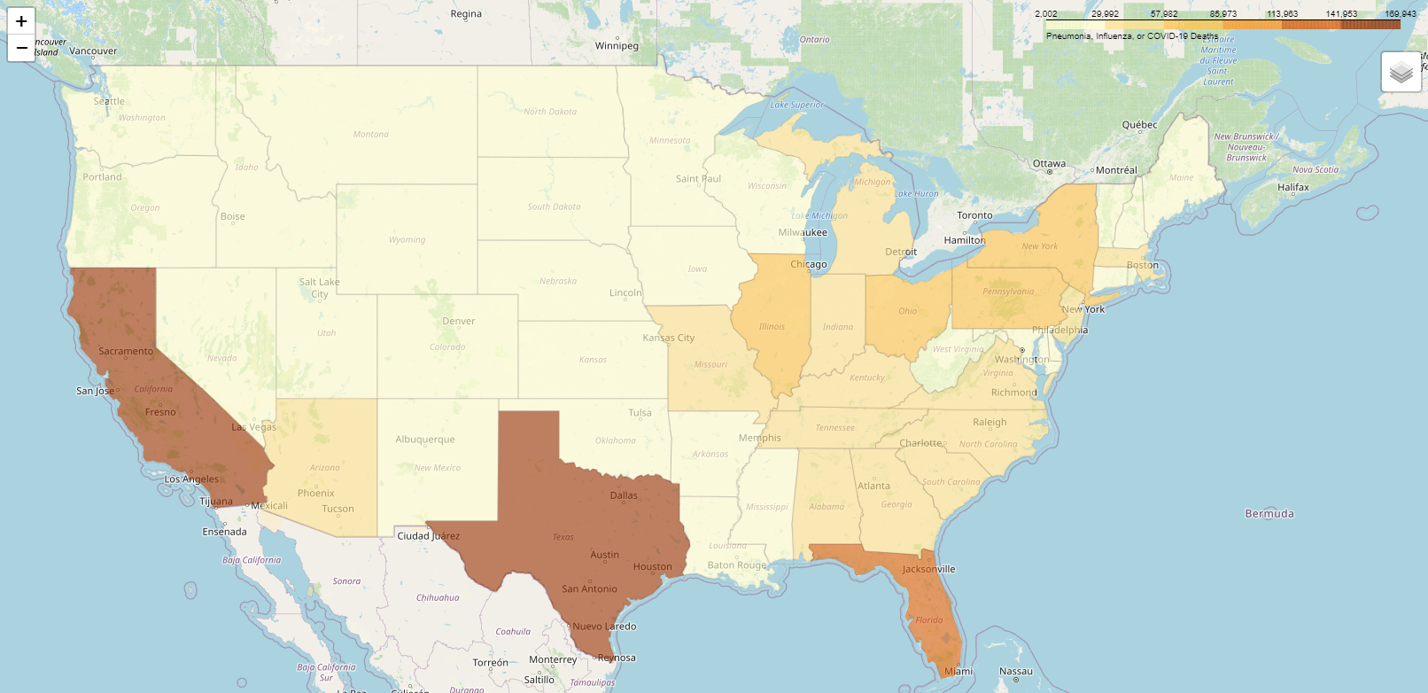

This shows us which states have the highest deaths due to one of the three illnesses

This tells us which age groups are most susceptible to death due to either of the illnesses.

This shows which months are most active for illness deaths.

* Include interpretations for each of your analyses’ results.
* Create a summary that states how your results are useful based on the initial research questions and hypothesis.

My results give information on time of year, state and age group lethality of the illnesses. It can give HealthCure information on how to make decisions using this information.

* Propose next steps for further analysis.

We can also see which illnesses are most lethal per age group. We can see if any of the illnesses are more lethal in different states.

* Include some limitations of your study.

Some limitations of the study is that we don’t have time series data about the deaths, so there are some ways that we cannot analyze the data.

1. Create your storyboard.
   * You may need to create additional visuals in Tableau to ensure the results are interpretable, the same as was done in the New Taipei City real estate example storyboard.
2. Ensure that your storyboard adheres to the visual design best practices introduced in [Exercise 2.2: Visual Design Basics & Tableau](https://careerfoundry.com/en/steps/visual-design-basics-tableau).
3. Publish your storyboard to the Tableau Public server and share a link with your mentor together with the project for the whole Achievement
   * Remember, Tableau Public is “public,” so be careful about posting any confidential data.

https://public.tableau.com/views/HealthCureStoryboard/Story1?:language=en-US&publish=yes&:display_count=n&:origin=viz_share_link